**Choco Banana [July 2023 Jane Street Puzzle]**

Problem: <https://www.janestreet.com/puzzles/choco-banana-index/> (credit to Jane Street)

Solution by Nicholas Patel

We first note the following properties:

* A 1 can only be in the region containing itself, therefore this region is a rectangle and the 1 must be shaded.
* If a prime number p is in a shaded region, that rectangular region must have shape 1xp or px1. More generally, the dimensions of a shaded region containing any number must be factors of that number (which multiply to that number).
* At most one distinct number can be in each region (shaded or unshaded), else there is a contradiction.
* Define a solution as an assignment of shades to the grid, which may or may not be feasible.
* The borders of all distinct shaded regions in any solution are ‘separated’, else, for example, two regions would be one (merged) region rather than two. Define the edge cells of a region as the subset of cells in the region which share a vertex with a cell not in the region. Then, 4-directionally connected cells of the edge cells which aren’t in the region must be the opposite shade. For example:

|  |  |  |  |  |
| --- | --- | --- | --- | --- |
| E | U | U | U |  |
| U |  |  | U |  |
| U |  |  | U |  |
| E | U | U | E | U |

U = must be unshaded, E = could be either

An example case of this is that two adjacent cells with different numbers must be in different components/regions and with different shades.

* The placement of numbers is completely symmetrical, about both the middle vertical line and the middle horizontal line, although I’m not sure how this information could be used to solve the problem more efficiently (if at all).

Manually, I started at the bottom right corner (with the 1, 7, 8 block) and ‘propagated’ the solution outwards. When I couldn’t get further, I then continued from the middle (3,4,5,6) block.

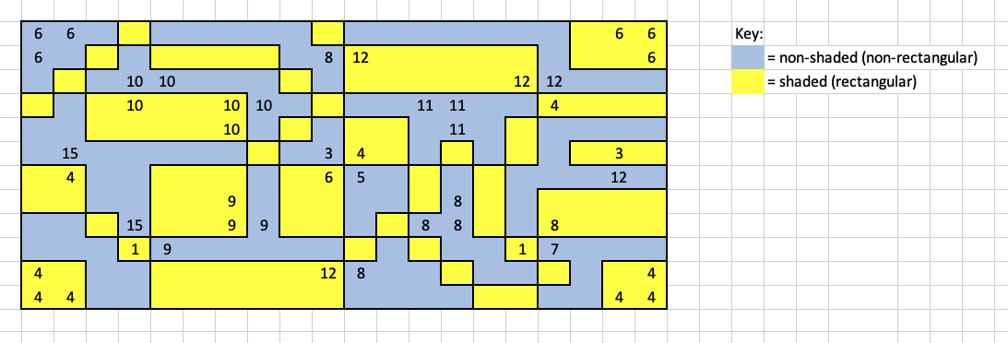The solution fell into place without too much ‘forward thinking’ needed, as follows:

Hence:

Answer = 15 x 6 x 12 x 9 x 11 x 12 x 11 x 7 x 8 x 16 x 8 x 8 = **809,321,103,360**